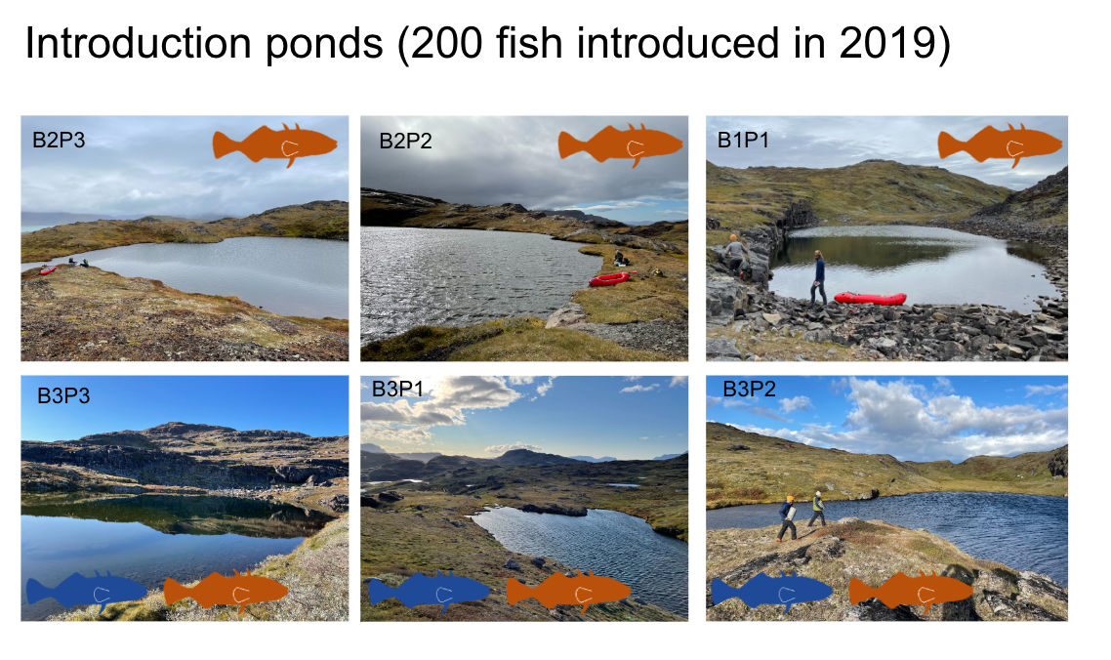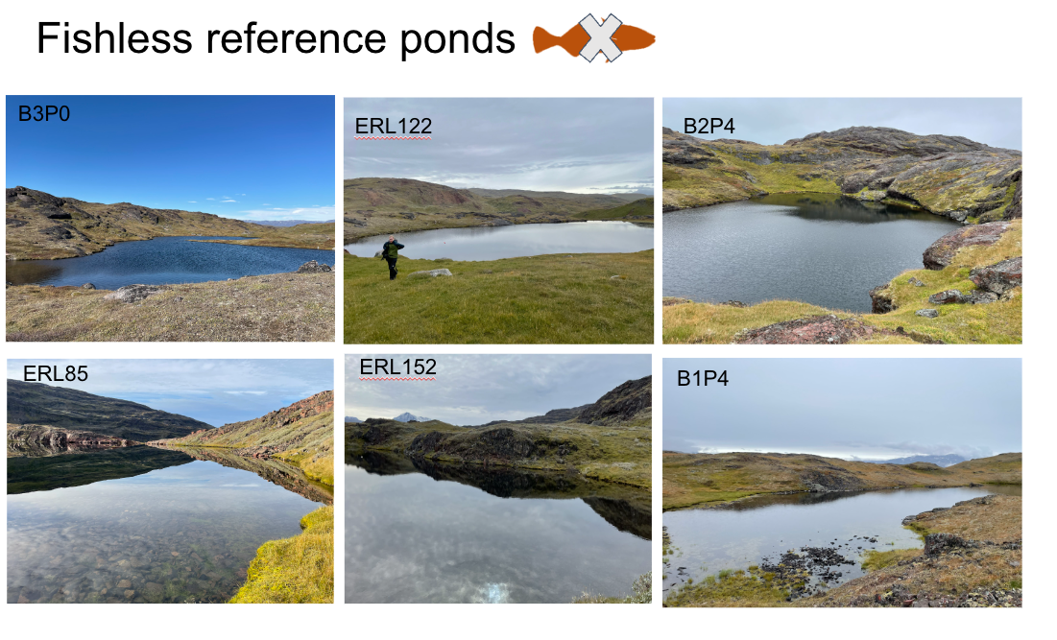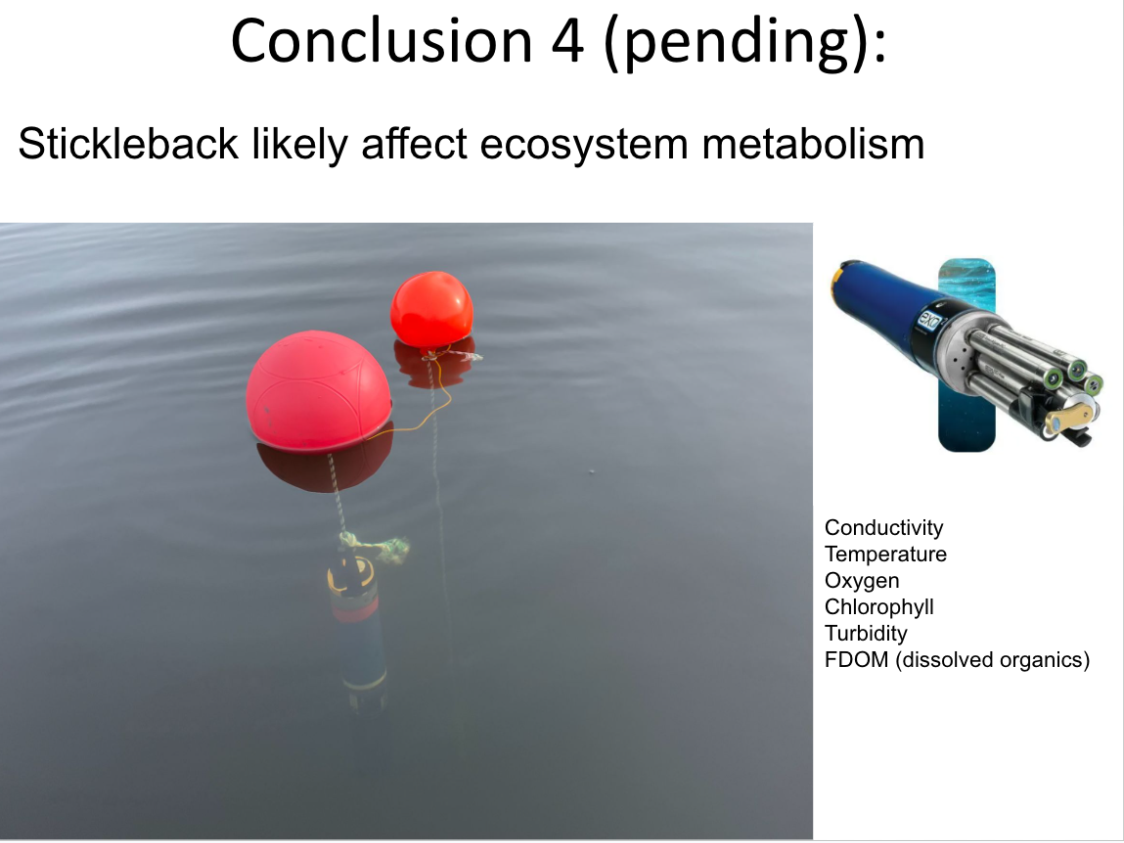

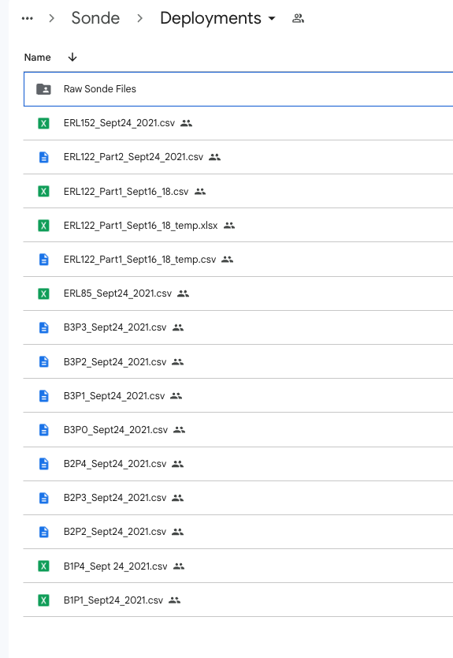

Column headings:

RFU - raw florescence

Cond- Conductivity

fDOM - fluorescent dissolved organic mater

ODO %sat - oxygen saturation

Sal - salinity

BGA - bluegreen algae

pH

Temp

2022 - data in raw for

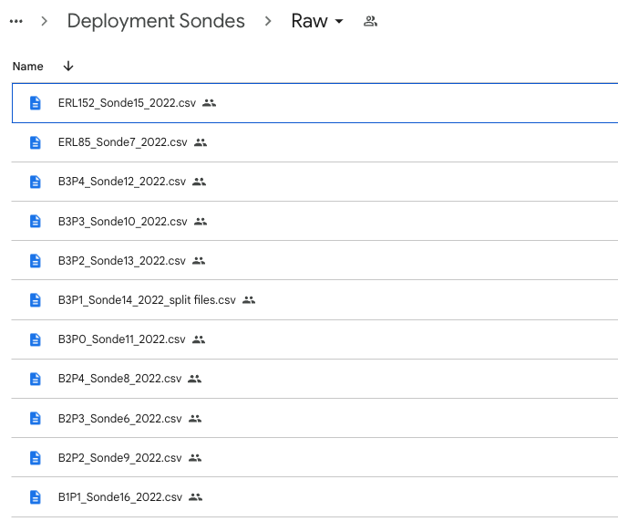

**Former PhD student:**

<https://github.com/mluerig?tab=repositories>

Data from a pond experiment deposited here: <https://osf.io/x6v9h/>

Paper described here: <https://doi.org/10.1002/ecy.3371>

Possible cleaning step or automated anomaly detection: <https://www.sciencedirect.com/science/article/pii/S1364815220309269>